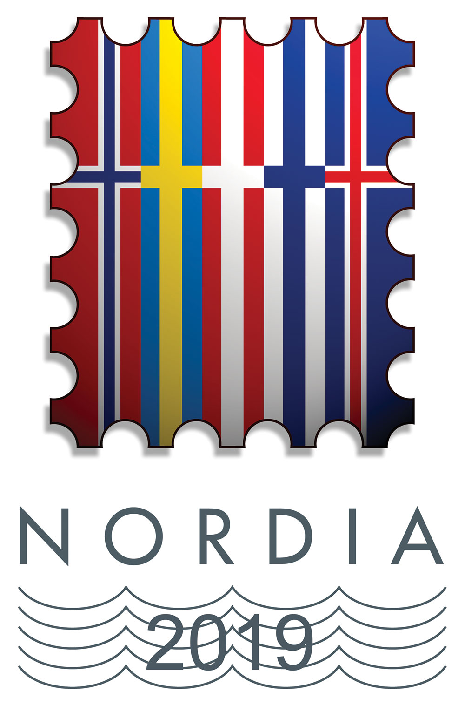 | NORDIA 2019  SARPSBORG  23. – 25. august 2019 | Eksponat nr. | Ramme nr.
 | Exhibition application form | For use of the exhibition committee

Exhibitor information
Name |  | Date of birth  (for youth exhibitors)
Pseudonym if applicable |  | Date of birth  (for youth exhibitors)
Street address |  | Date of birth  (for youth exhibitors)
Postal code | City | Country
Phone number | E-mail address

Exhibit information
Title

Short description

Class | No. of frames applied for | Max sheet size (h) including protection sheet: 307 mm

Delivery, mounting and dismounting of the exhibit
Exhibitor or his/her representative will deliver the exhibit |  | The exhibit will be delivered by mail
Exhibitor or his/her representative will mount the exhibit |  | Exhibition committee will mount the exhibit
Exhibitor or his/her representative will dismount the exhibit |  | Exhibition committee will dismount the exhibit

Past awards received by the exhibit
International (FIP/FEPA/NORDIA) exhibitions | LG | G | LV | V | LS | S | SB | B
National exhibitions |  | G | LV | V | LS | S | SB | B

I hereby accept all the FIP regulations and the Nordia 2019 special regulations
Place | Date
Signature of the exhibitor
(youth exhibitors also need approval from parents)
Signature of commissioner

Send the application form to your local commissioner. Norwegian citizens email: mail@nordia2019.no
Don’t forget the plan and synopsis if applicable

